**> fl <- c(2.77, 0.76, 0.76, 1.37, 1.52, 1.66, 1.35, 1.52, 1.70, 1.62, 1.84, 1.60, 2.07, 2.03, 1.88, 1.75, 1.82, 2.71, 2.05, 2.11, 2.32, 2.35, 2.11, 2.35, 2.32, 2.73, 2.12, 2.36, 2.14, 2.29, 2.57, 2.05, 2.33, 2.59, 2.30, 2.59, 2.57, 2.57, 2.57, 2.61, 2.57, 2.57, 2.57, 2.61, 2.44, 2.59, 2.37, 2.46, 2.60, 2.45, 2.28, 2.40, 2.27, 2.71, 2.98, 2.45, 2.96, 2.35, 2.71, 2.72, 2.53, 2.95, 2.73, 2.65, 2.68, 3.16, 2.97, 3.18, 2.89, 2.63, 2.84, 2.91, 2.92, 3.14, 2.72, 2.88, 3.23, 2.71, 3.23, 3.23, 3.23, 3.23, 3.26, 3.37, 3.24, 3.11, 3.22, 3.00, 3.26, 3.45, 3.43, 3.75, 3.29, 3.27, 3.52, 3.71, 3.65, 4.00, 3.76, 4.12, 4.11, 3.76, 4.30, 3.93, 4.12, 4.12, 4.07, 4.53, 4.45, 4.42, 4.71, 4.24, 4.33, 4.12, 4.62, 4.22, 4.24, 4.34, 4.46, 4.34, 4.19, 4.31, 3.96, 4.47, 4.54, 4.82, 4.67, 4.63, 4.82, 4.69, 4.48, 4.69, 4.69, 4.32, 4.82, 4.49, 4.87, 4.58, 5.02, 4.74, 4.95, 4.52, 4.97, 4.91, 4.77, 4.84, 4.87, 4.75, 4.74, 5.04, 5.05, 4.75, 5.05, 5.05, 5.14, 5.16, 5.25, 5.08, 4.93, 5.30, 5.17, 5.32, 4.75, 5.02, 5.26, 5.79, 5.65, 5.12, 5.49, 5.17, 5.57, 5.60, 5.14, 5.27, 5.12, 5.24, 5.62, 5.64, 5.71, 5.62, 5.68, 6.36, 5.66, 5.77, 5.52, 5.31, 5.42, 5.94, 5.91, 5.92, 5.67, 6.19, 5.69, 6.55, 5.59, 6.46, 5.90, 5.71, 5.80, 5.68, 5.56, 5.83, 6.25, 5.75, 6.33, 6.39, 6.25, 5.75, 6.04, 5.99, 5.80, 6.59, 6.11, 5.83, 5.83, 5.82, 6.19, 6.11, 6.35, 6.41, 6.20, 5.97, 6.43, 6.28, 6.22, 5.81, 6.41, 6.17, 6.19, 5.96, 5.75, 6.48, 6.09, 6.17, 6.18, 6.20, 5.96, 5.68, 5.89, 6.03, 5.99, 5.89, 5.83, 6.32, 6.55, 6.61, 6.59, 6.09, 6.36, 6.66, 6.54, 6.24, 6.42, 6.36, 6.15, 6.36, 6.20, 5.97, 6.07, 6.23, 6.25, 6.28, 6.39, 6.53, 6.20, 6.58, 6.53, 6.51, 6.23, 6.28, 6.39, 6.77, 6.58, 6.56, 6.61, 7.01, 7.43, 7.15, 6.65, 7.01, 7.06, 6.81, 7.07, 6.86, 7.24, 6.89, 6.99, 7.03, 6.84, 7.09, 7.12, 7.52, 6.79, 7.17, 6.71, 7.46, 6.98, 7.14, 7.27, 6.71, 6.96, 6.92, 7.34, 7.62, 7.52, 7.13, 6.92, 6.99, 6.94, 7.23, 7.30, 6.87, 6.82, 7.05, 7.03, 7.14, 7.12, 7.39, 6.91, 7.09, 7.00, 6.28, 7.33, 8.08, 7.47, 7.21, 7.77, 7.36, 6.56, 7.01, 7.15, 7.11, 7.41, 7.48, 7.16, 7.89, 7.20, 7.78, 8.29, 7.12, 7.22, 7.29, 7.20, 7.21, 7.11, 7.27, 7.13, 7.20, 7.20, 8.32, 7.00, 7.48, 7.53, 7.25, 7.22, 7.28, 7.03, 7.33, 7.26, 7.80, 7.29, 7.31, 7.70, 7.31, 7.38, 7.62, 7.15, 7.24, 7.15, 7.41, 7.24, 8.29, 7.59, 8.10, 7.93, 7.46, 7.33, 6.95, 8.31, 7.47, 7.92, 7.37, 7.62, 7.77, 7.41, 7.88, 7.88, 7.88, 7.64, 8.79, 7.66, 7.66, 8.19, 7.18, 7.61, 7.68, 8.51, 7.59, 7.75, 7.61, 7.57, 7.27, 8.06, 8.51, 7.68, 7.87, 8.12, 7.35, 7.97, 7.76, 7.59, 7.44, 7.23, 8.22, 7.32, 7.96, 7.62, 7.59, 8.06, 6.91, 8.52, 7.93, 7.99, 8.12, 7.41, 8.50, 7.83, 7.95, 7.86, 8.05, 8.50, 7.63, 8.08, 8.21, 7.92, 7.70, 8.01, 8.12, 7.40, 7.15, 7.79, 7.92, 7.66, 7.58)**

**> ga <- c(11, 12, 12, 13, 13, 13, 13, 14, 14, 14, 14, 14, 15, 15, 15, 15, 15, 15, 15, 16, 16, 16, 16, 16, 16, 16, 16, 16, 16, 16, 16, 16, 16, 16, 16, 16, 17, 17, 17, 17, 17, 17, 17, 17, 17, 17, 17, 17, 17, 17, 17, 17, 17, 17, 17, 17, 17, 17, 17, 17, 17, 17, 17, 17, 17, 18, 18, 18, 18, 18, 18, 18, 18, 18, 18, 18, 18, 18, 19, 19, 19, 19, 19, 19, 19, 19, 19, 19, 19, 19, 20, 20, 20, 20, 20, 20, 20, 22, 22, 22, 22, 22, 22, 22, 23, 23, 23, 23, 23, 23, 23, 23, 23, 23, 23, 23, 23, 23, 23, 23, 23, 23, 23, 23, 23, 24, 24, 24, 24, 24, 24, 24, 24, 24, 24, 24, 24, 25, 25, 25, 25, 25, 25, 25, 25, 25, 25, 25, 25, 25, 26, 26, 26, 26, 26, 26, 26, 26, 26, 26, 26, 26, 26, 26, 27, 27, 27, 27, 27, 27, 27, 27, 27, 27, 27, 27, 28, 28, 28, 28, 28, 28, 28, 28, 28, 28, 28, 28, 29, 29, 29, 29, 29, 29, 29, 29, 29, 29, 29, 29, 29, 30, 30, 30, 30, 30, 30, 30, 30, 30, 30, 30, 30, 30, 30, 30, 30, 30, 30, 30, 30, 30, 30, 30, 30, 30, 30, 30, 30, 30, 30, 30, 30, 30, 30, 30, 30, 30, 30, 30, 30, 30, 30, 31, 31, 31, 31, 31, 31, 31, 31, 31, 31, 31, 31, 31, 31, 31, 31, 31, 31, 31, 31, 31, 32, 32, 32, 32, 32, 32, 32, 33, 33, 33, 33, 33, 33, 34, 34, 34, 34, 34, 34, 34, 34, 34, 34, 34, 34, 34, 34, 35, 35, 35, 35, 35, 35, 35, 35, 35, 35, 35, 35, 35, 35, 35, 35, 35, 35, 35, 35, 35, 35, 35, 35, 35, 35, 35, 35, 35, 35, 35, 36, 36, 36, 36, 36, 36, 36, 36, 36, 36, 36, 36, 36, 36, 36, 36, 36, 36, 36, 36, 36, 36, 36, 36, 36, 37, 37, 37, 37, 37, 37, 37, 37, 37, 37, 37, 37, 37, 37, 37, 37, 37, 37, 37, 38, 38, 38, 38, 38, 38, 38, 38, 38, 38, 38, 38, 38, 38, 38, 38, 38, 38, 38, 38, 38, 38, 38, 38, 38, 38, 38, 38, 38, 39, 39, 39, 39, 39, 39, 39, 39, 39, 39, 39, 39, 39, 39, 39, 39, 39, 39, 39, 39, 39, 39, 39, 39, 39, 39, 39, 39, 40, 40, 40, 40, 40, 40, 40, 40, 40, 40, 40, 40, 40, 40, 40, 40, 40, 40, 41, 41, 41)**

**> data <- data.frame(ga, fl)**

**> plot(data$ga, data$fl, type="b")**

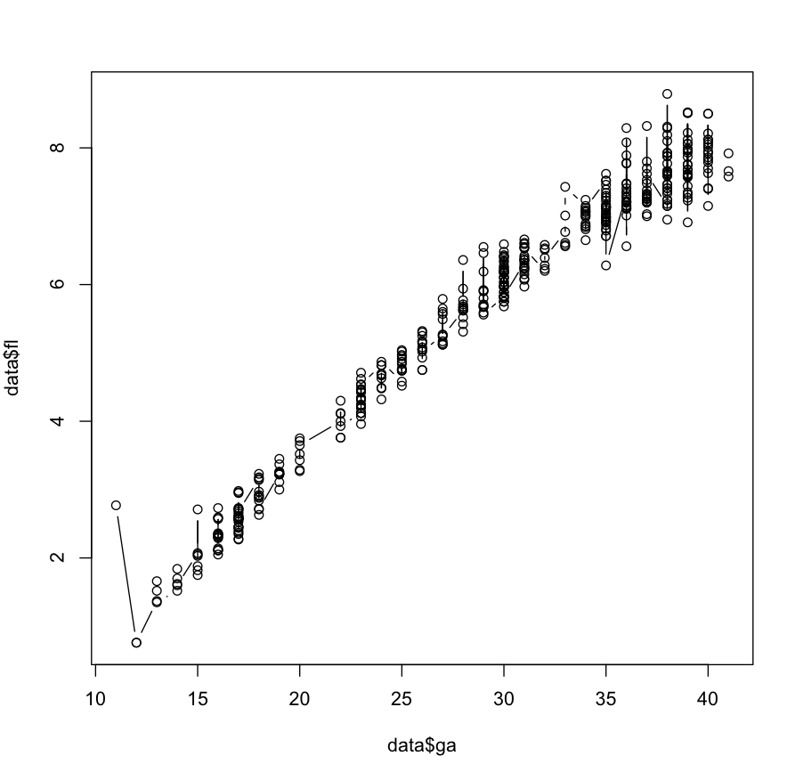

**> fit1 <- lm(data$fl ~ data$ga)**

**> fit2 <- lm(data$fl ~ data$ga + I(data$ga^2))**

**> fit3 <- lm(data$fl ~ data$ga + I(data$ga^2) + I(data$ga^3))**

**> fit2b <- lm(data$fl ~ poly(data$ga, 2, raw=TRUE))**

**> fit3b <- lm(data$fl ~ poly(data$ga, 3, raw=TRUE))**

**> summary(fit2)**

*Call:*

*lm(formula = data$fl ~ data$ga + I(data$ga^2))*

*Residuals:*

*Min 1Q Median 3Q Max*

*-0.88046 -0.17520 -0.02335 0.14102 2.07291*

*Coefficients:*

*Estimate Std. Error t value Pr(>|t|)*

*(Intercept) -3.4888447 0.1730998 -20.16 <2e-16 \*\*\**

*data$ga 0.4164174 0.0133402 31.21 <2e-16 \*\*\**

*I(data$ga^2) -0.0032617 0.0002412 -13.52 <2e-16 \*\*\**

*---*

*Signif. codes: 0 ‘***’ 0.001 ‘**’ 0.01 ‘*’ 0.05 ‘.’ 0.1 ‘ ’ 1*

*Residual standard error: 0.2875 on 441 degrees of freedom*

*Multiple R-squared: 0.9781, Adjusted R-squared: 0.978*

*F-statistic: 9831 on 2 and 441 DF, p-value: < 2.2e-16*

The equation of the 2nd order polynomial is:

f(x) = -3.4888447 + 0.4164174x - 0.0032617 x^2

If we search for a 3rd order polynomial:

**> summary(fit3)**

Call:

lm(formula = data$fl ~ data$ga + I(data$ga^2) + I(data$ga^3))

*Residuals:*

*Min 1Q Median 3Q Max*

*-0.86013 -0.18050 -0.01885 0.14967 1.76222*

*Coefficients:*

*Estimate Std. Error t value Pr(>|t|)*

*(Intercept) -1.239e+00 6.094e-01 -2.034 0.042565 \**

*data$ga 1.374e-01 7.376e-02 1.862 0.063243 .*

*I(data$ga^2) 7.537e-03 2.819e-03 2.674 0.007773 \*\**

*I(data$ga^3) -1.320e-04 3.434e-05 -3.845 0.000138 \*\*\**

*Signif. codes: 0 ‘***’ 0.001 ‘**’ 0.01 ‘*’ 0.05 ‘.’ 0.1 ‘ ’ 1*

*Residual standard error: 0.2831 on 440 degrees of freedom*

*Multiple R-squared: 0.9788, Adjusted R-squared: 0.9786*

*F-statistic: 6764 on 3 and 440 DF, p-value: < 2.2e-16*

And the equation should be:

f(x) = -1.239e+00 +1.374e-01x + 7.537e-03x^2 -1.320e-04x^3

**> plot(data$ga, data$fl, type="l", lwd=3)**

Adding the 2nd order polynomial:

**> points(data$ga, predict(fit2), type="l", col="red", lwd=2)**

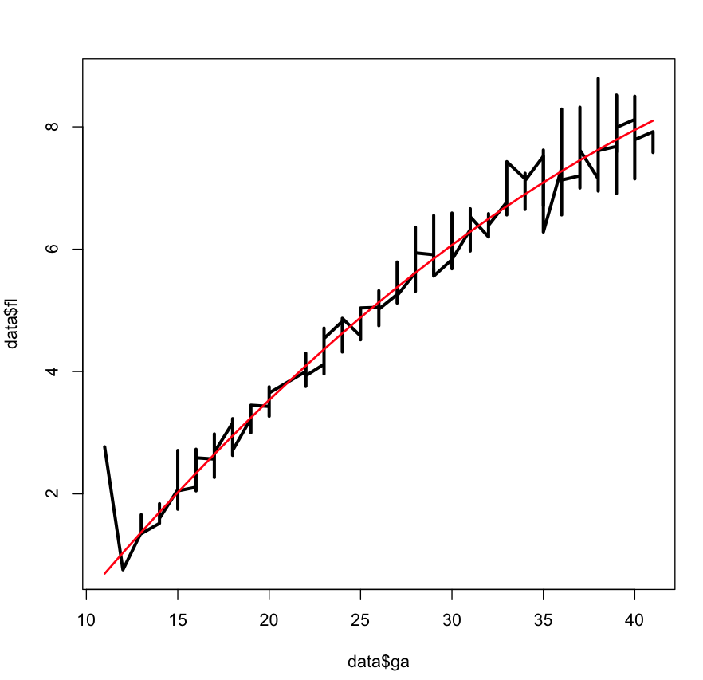

Adding the 3rd order polynomial:

**> points(data$ga, predict(fit3), type="l", col="blue", lwd=2)**

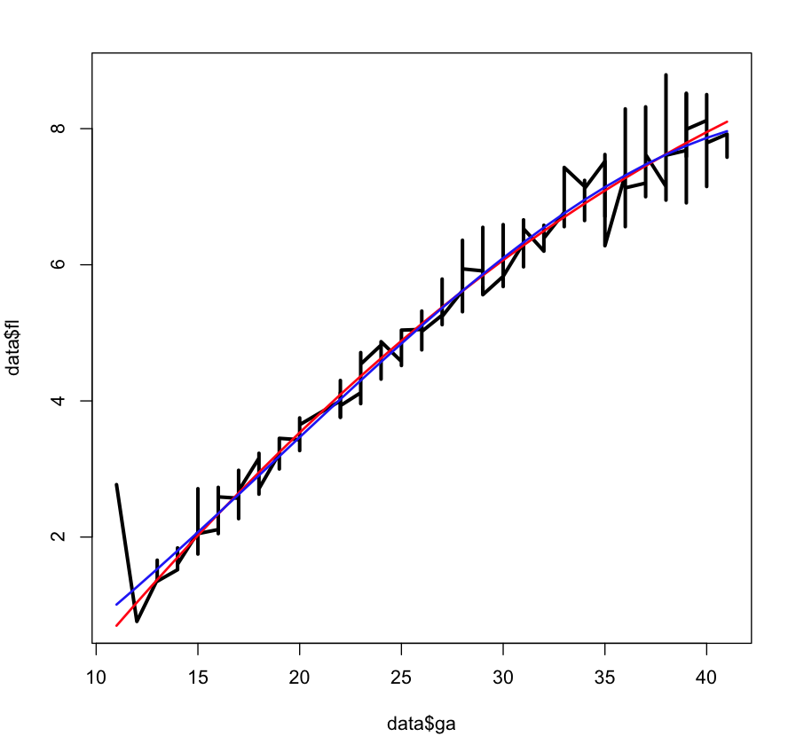

Another method:

**> and2 <- function(x) fit2$coefficient[3]*x^2 + fit2$coefficient[2]*x + fit2$coefficient[1]**

**> plot(data$ga, data$fl, type="p", lwd=3)**

**> and2 <- function(x) fit2$coefficient[3]*x^2 + fit2$coefficient[2]*x + fit2$coefficient[1]**

**> curve(and2, col="red", lwd=2)**

Replace the points:

**> plot(data$ga, data$fl, type="p", lwd=3)**

**> points(data$ga, predict(fit2), type="l", col="blue", lwd=2)**

**> points(data$ga, predict(fit3), type="l", col="red", lwd=2)**

